CL-1002 Programming Fundamentals
Lab - 10
Instructor: Samia Mujahid | Email: | samia.mujahid@nu.edu.pk
Section: BCS-1C | Due Date: | 25-Oct-2024
 | Time: 4:30 pm

Objectives:
- Practice and understanding of basic C++ programs
- Nested Loop
- 1-D Array

Note: Carefully read the following instructions (Each instruction contains a weightage)
- First think about statement problems and then write/draw your logic on copy.
- Microsoft Visual Studio should be used to make C++ programs. Programs made with any other software would not be accepted.
- For each task in the manual create a new C++ program with the naming convention as follows: TASK-NO
- Mention what is happening in each line of code using comments.
- Write all codes one by one with proper numbering and paste a screenshot of each problem using the snipping tool (default screen capture software in Windows) on a Microsoft Word file + Make one ZIP file of your all source codes.
- Use proper font family (Calibri or Times New Roman) and font size of title (16 points), heading (14 points), subheading (12 points), and normal text (10 points).
- Do not copy from any source otherwise you will be penalized with negative marks.
- Please submit your Both files with this name 24F1234_lab10.
- Submit your lab on Google Classroom.
- Complete your lab within the given Time Slot.
- You have to implement each task using nested loops and 1D- Arrays.
Task no 1: Make the following shape with asterisk. Also, the size of the Hour glass will be defined by user
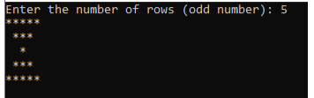
Task no 2: Make the following shape with asterisk. Also, the size of the butterfly will be defined by user.
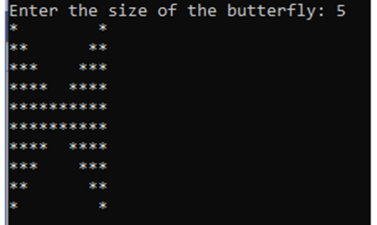
Note: Properly comment each important line in code

Task no 3:
Write a program that takes an integer n from the user and uses nested loops to display a pyramid of numbers with n rows. For example, if n = 5, the output should be:
Output
1
1 2
1 2 3
1 2 3 4
1 2 3 4 5
Note: Properly comment each important line in code

Task no 4: Calculating Power of Numbers
Scenario: Given an array of 10 base numbers, each needs to be raised to powers from 1 through 10.
Write a C++ program that:
- Uses a nested loop to calculate each power value and stores the results in a one-dimensional array.
- Displays the computed power values for each base number.

Task no 5: Recording Study Hours
Scenario: A student wants to keep track of their study hours throughout each day over the course of a week, logging multiple study sessions per day.
Write a C++ program that:
- Uses a nested loop to input the number of hours studied in each session for each of the 7 days.
- Calculates and displays the total study hours for each day.
- Computes and outputs the overall total study hours for the entire week.
Task no 6:
Write a C++ program that creates two integer arrays of size = 5. Take the input from the user in array 1 and program should insert the second array in reverse order. Display the content of both arrays.
For Example,
Array 1: [1, 2, 3, 4, 5]
Array 2: [5, 4, 3, 2, 1]
Task no 7:
A sales manager wants to monitor daily sales of a specific product over a period of 5 days. The product is sold multiple times each day, and the manager wants a breakdown of sales by day and an overall total. Write a C++ program to achieve this. The program should:
- Use a nested loop to input the number of sales transactions for each day across 5 days (e.g., Day 1 might have 4 sales transactions, Day 2 might have 3, etc.).
- Calculate and display the total sales for each individual day.
- Compute and output the overall total sales for all 5 days combined.
Good Luck😊

